LABAQM - A System for Qualitative Modelling and Analysis of Animal Behaviour

Maja Matetić¹, Slobodan Ribarić² and Ivo Ipšić¹

¹Faculty of Philosophy, University of Rijeka, maja@pefri.hr, ivoi@pefri.hr
²Faculty of Electrical Engineering and Computing, University of Zagreb, slobodan.ribaric@fer.hr

Abstract: Tracking of a laboratory animal and its behaviour interpretation based on frame sequence analysis have been traditionally quantitative and typically generates large amounts of temporally evolving data. In our work we are dealing with higher-level approaches such as conceptual clustering and qualitative modelling in order to represent data obtained by tracking. We present the LABAQM system developed for the analysis of laboratory animal behaviours. It is based on qualitative modelling of animal motions. We are dealing with the cognitive phase of the laboratory animal behaviour analysis as a part of the pharmacological experiments. The system is based on the quantitative data from the tracking application and incomplete domain background knowledge. The LABAQM system operates in two main phases: behaviour learning and behaviour analysis. The behaviour learning and behaviour analysis phase are based on symbol sequences, obtained by the transformation of the quantitative data. Behaviour learning phase includes supervised learning procedure, unsupervised learning procedure and their combination. The fusion of supervised and unsupervised learning procedures produces more robust models of characteristic behaviours, which are used in the behaviour analysis phase.

Keywords: dynamic vision system, qualitative modelling, conceptual clustering, hidden Markov models of characteristic behaviours.

1. INTRODUCTION
The paper deals with the problem of the off-line analysis and recognition of laboratory animal behaviour during pharmacological experiments. The quantitative data are obtained by the tracking system described in [7, 8]. Using the background knowledge of an expert, a spatio-temporal model, conceptual clustering [9, 17] and qualitative modelling [3, 4], the animal behaviour analysis and recognition of behaviours are performed. Qualitative modelling can be used for interpretation, making conclusions and predictions of the system behaviour, even without complete data [5, 10].

During the last two decades, the number of papers within the field of human behaviour capture using computer vision has grown significantly. Aggarwal et al. [1] describe the human motion capture problem as: action recognition, recognition of the individual body parts and body configuration estimation. In the survey given by Moeslund and Granum [19] the focus is on a general overview based on taxonomy of system funcionalities, broken down into four processes: initialisation, tracking, pose estimation and recognition. An example of action recognition systems developed for the visual suirveillance task is described in [16].

Gavrila in [6] gives an overview of two-dimensional approaches that do not consider explicit shape of objects. This approaches have been especially popular for applications of hand pose estimation in sign language recognition and gesture-based dialogue management. There are several approaches considering the motion trajectories of the hand centroids [22, 23]. Moeslund and Granum [19] predict that the field of object motion capture will find inspiration in methods from speech recognition. According to [19] the essential problem is the lack of a general underlying modelling language, i.e. how to map the images into symbols. The work of Bregler [2] introduces such an idea of representing motion data by "movemes" (similar to phonemes in speech recognition). This type of high level symbolic representation is also used in the work by Wren et al. [24]. Starner and Pentland in [22] present two real-time hidden Markov model-based systems for recognising sentence-level continuous American Sign Language using a single camera to track the user's hands.

An overview of the latest research in the field of qualitative spatial representation and reasoning is given by Cohn and Hazarika [4]. Qualitative Spatial Reasoning (QSR) has been used in computer vision for visual object recognition at a higher level which includes the interpretation and integration of visual information.

The paper is organised as follows: Problem description is given in Section 2. In Section 3 we describe the LABAQM system, for the laboratory animal behaviour analysis. Section 4 introduces feature vector transformation procedure. The supervised and the unsupervised behaviour learning procedures and their combination are described in Section 5. In Section 6 the results of behaviour analysis are given.

2. PROBLEM OF OBJECTS BEHAVIOUR ANALYSIS

Our goal is to implement a system for automated experiment monitoring, ensuring an objective evaluation of animal behaviour. The system is being developed for behaviour analysis of moving animals in a cage. The system is used to release human operators from the tedious job of time-consuming monitoring of the experiments, measuring time intervals and counting some events. The system introduces objectiveness and standard evaluation of animal behaviours during pharmacological experiments.

We are dealing with the cognitive phase of the laboratory animal behaviour analysis and recognition as a part of the pharmacological experiments. Each of the object trajectories is presented by a sequence of feature vectors. A feature vector describes the position and orientation of the object in an object trajectory point. Feature vectors are obtained from the dynamic vision system [7, 8] (Figure 1). Object motion during n consecutive frames is presented by an n-tuple of feature vectors:
(((x₁,y₁),Θ₁),((x_{2,},y₂),Θ₂),...,((x_{n-1},y_{n-1}),Θ_{n-1}),((x_{n},y_{n}),Θ_{n})) (1)
The behaviour analysis procedures are based on the following assumptions: The subject remains inside the scene, there is no camera motion, only one object is in the scene at the time, subject moves on a flat ground plane, there is no occlusion.

3. SYSTEM FOR THE LABORATORY ANIMAL BEHAVIOUR ANALYSIS BASED ON QUALITATIVE MODELLING - LABAQM

The LABAQM system for laboratory animal behaviour analysis operates in two main phases: behaviour learning and behaviour analysis. The learning and behaviour analysis phase are based on symbol sequences, obtained by the feature vector transformation of quantitative data.
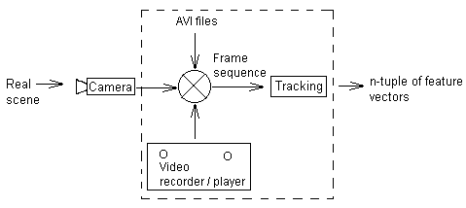
Figure 1: Dynamic vision system

3.1. FEATURE VECTOR TRANSFORMATION

Object motion description represented by n-tuple of feature vectors obtained by the dynamic vision system represents the input data to the feature vector transformation procedure (Figure 2). The background knowledge base consists of chunks of the incomplete knowledge about behaviour attributes described by the problem domain expert. To perform the conceptual clustering procedure of the animal behaviour a spatio-temporal model is proposed. We have decided to use rectangle elementary regions which are adapted to the object dimensions.
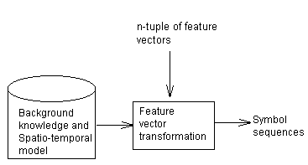

Figure 2: Feature vector transformation

3.2. BEHAVIOUR LEARNING PHASE

Behaviour learning phase comprises three subphases: Supervised learning, unsupervised learning and their fusion. Before the learning phases the feature vector transformation procedure is applied. Supervised learning includes the characteristic behaviour modelling procedure (Figure 3). Unsupervised learning includes the conceptual clustering subphase (Figure 4). Due to insufficient background knowledge given by an expert and the assumptions related to the motion capture system we propose a fusion of supervised and unsupervised learning procedures. The fusion of supervised and unsupervised learning procedures produces more robust models of characteristic behaviours which are used in the behaviour analysis and recognition phases.

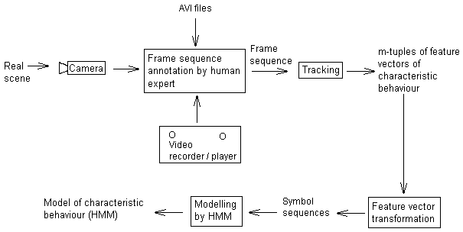
Figure 3: Behaviour supervised learning
3.2.1. SUPERVISED LEARNING SUBPHASE

An expert has to choose inserts of video sequences representing characteristic behaviours. The expert can choose video sequences from real-time recordings, from previous recordings given by the video player or by avi files stored on an external memory. These video sequences are inputs in the dynamic vision system [7, 8]. The selected m-tuples of feature vectors represent characteristic behaviours, where m<n and m represents the number of feature vectors in an experiment observation. The m-tuple of feature vectors is then transformed by the feature vector transformation procedure into sequences of symbols. The sequences of symbols are modelled by HMMs (Figure 3).

3.2.2.UNSUPERVISED LEARNING SUBPHASE

The number of available symbol sequences, used in HMM supervised training, is too small to be used for robust modelling of characteristic behaviours. Larger sets of symbol sequences representing the characteristic behaviours can be obtained by an unsupervised learning method, such as conceptual clustering [9, 17]. At this subphase (Figure 4) the hierarchical clustering method [11] is used to find clusters of input symbol sequences. The similarity measure used for the clustering procedure is based on the Levenshtein distance [12]. The conceptual clustering method and experimental results are presented in more details in Section 5.
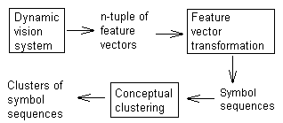

Figure 4: Behaviour unsupervised learning

3.2.3. FUSION OF SUPERVISED AND UNSUPERVISED LEARNING

Symbols sequences from clusters obtained by conceoptual clustering are analysed by the HMMs of characteristic behaviours obtained in the supervised learning phase. Symbol sequences representing characteristic behaviours chosen by an expert are joined with symbol sequences from clusters describing similar behaviours. Characteristic behaviour models are obtained by HMM modelling of these joined symbol sequences (Figure 5). The experimental results of the fusion method are given in Section 5.

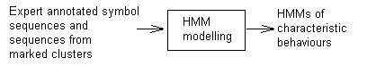

Figure 5: Fusion of supervised and unsupervised learning

3.3. BEHAVIOUR ANALYSIS

HMMs resulting from the fusion of supervised and unsupervised learning are used in the behaviour analysis of unknown behaviours (Figure 6). On the base of expert knowledge it is known that nontreated animal behaviour is characterised by slow motion, while the behaviour of treated animals is characterised by cycling motion. Recognition results using these behaviours modelled by HMMs are represented in Section 6.
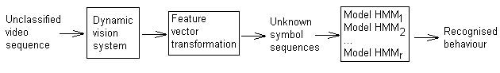
Figure 6: Behaviour analysis phase

4. FEATURE VECTOR TRANSFORMATION

The spatio-temporal model has to represent not only everyday commonsense knowledge about physical world, but also the underlying abstractions used by experts when they create models [3, 5]. A qualitative representation of the scene is symbolic and it utilizes discrete quantity spaces. These discretisations must be relevant to the behaviour being modelled, i.e. distinctions are only introduced if they are necessary to model some particular aspect of the domain with respect to the task in hand. Traditionally, in mathematical theories of space, points are primary primitive spatial entities. However, within the qualitative spatial reasoning community, there has been a strong tendency to take regions of space as primitive spatial entities [4].

The information provided from the dynamic vision system [7, 8] is, by nature, quantitative and described by n-tuples of feature vectors (Equation 1) for the object in the scene. The laboratory animal behaviour analysis is based on orientation quantisation and also on the quantisation of the two-dimensional space. Using the approximate zone or region rather than the exact object location the similar behaviours will be joined into common classes. A scene cannot be arbitrarily segmented into regions, but the regions should be conceptually relevant to the physical structure of the domain rather than arbitrary.

4.1. QUALITATIVE REGION

In the first step we deal with the topology description of the scene. To enable the detection of relevant qualitative changes in space, a rectangle mesh is used. We have used the proper spatial extension of object projection in a two-dimensional space in order to obtain elementary rectangle of the mesh (Figure 7).
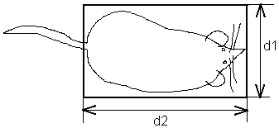
Figure 7: Spatial extension of the laboratory animal

The mesh is the result of a bisection of the scene in a two-dimensional space. The expert can choose values for qualitative region attribute by marking those elementary rectangles by symbols from a finite alphabet. The elementary rectangles are then unified, resulting in a new topology frame, where qualitative regions are of different shapes and sizes (Figure 8). The size and the shape of qualitative regions depend on the frequency of animal visits of a qualitative region in the scene.

4.2. QUALITATIVE ORIENTATION
The second attribute of modelling is the qualitative orientation. It is considered within the qualitative region and it is defined as a mapping QO ( Table 1).

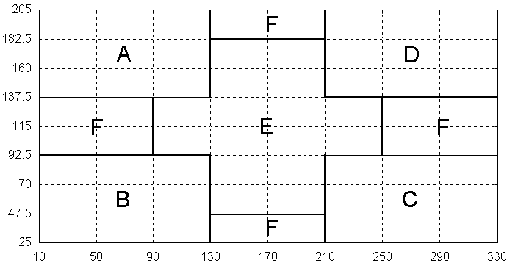
Figure 8: Qualitative regions

Θ [°] | [0°,90°) | [90°,180°) | [180°,270°) | [270°,360°)
QO(Θ) | 1 | 2 | 3 | 4
Table 1: The definition of qualitative orientation mapping

To describe the activity inside a qualitative region we define t_{a} as the average time duration between two changes of the qualitative orientation. It is defined as the quotient ⎡c1/c2⎤ (ceiling number of quotient c1/c2), where c1 represents time an animal spent in a qualitative region and c2 is the number of the qualitative orientation changes of an animal inside the qualitative region. c1 is expressed by the number of frames. The value of t_{a} is quantised into three intervals represented by t_{aq}. The range of the intervals is selected by an expert. The ranges of the intervals are: first interval, denoted by t_{aq}=1, is [1,3]; second interval, denoted by t_{aq}=2, is (3,6] and third interval, denoted by t_{aq} =3, is (6,400].

4.3.FEATURE VECTOR TRANSFORMATION ALGORITHM
The transformation algorithm is based on the spatio-temporal model and the input data obtained by tracking (Equation (1)). It produces the set of qualitative behaviour attributes. The transformation algorithm we have described in more details in [13, 14, 15]. The transformation example is given in Figure 9.

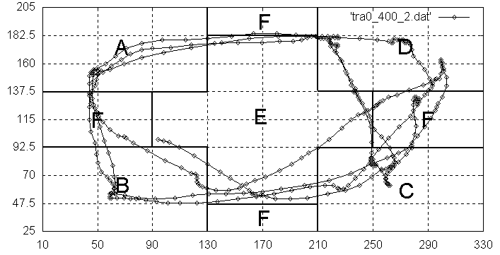
qb = F C C E E B F F A E E D F F C C E E B F F A A E F E D E D E E C C F F D D F F F E E C E E E B B B F F F A E E E D E E F C C E B E E

Figure 9: Transformation algorithm example

5. LEARNING

5.1. SUPERVISED LEARNING

An expert selects characteristic behaviours by marking video inserts of interest. The characteristic animal behaviours chosen by an expert are modelled by HMMs, in the modelling substage (Figure 3). The chosen inserts are transformed in the feature vector transformation substage to symbol sequences. Some relevant data of the chosen video inserts and the feature vector transformation results are given in Table 2. The tr₀ - tr₂ observations represent frame sequences of treated animals and ntr₀ - ntr₂ represent frame sequences of nontreated laboratory animals. The expert has chosen three types of characteristic behaviours according to the kind of the pharmacological treatment: Slow motion, counter-clockwise cycling (ABCD) and clockwise cycling (ADCB). The set of symbol sequences obtained by feature vector transformation procedure is used for training hidden Markov models (HMMs) of characteristic behaviours.

 | 1. Slow motion | 2. Counter-clockwise cycling (ABCD) | 3. Clockwise cycling (ADCB)
Total time duration of video inserts chosen by the expert [minutes] | 65 | 25 | 30
Observations from which video inserts are chosen | ntr₀, ntr₁ | tr₀, tr₁, tr₂ | tr₀
Number of annotated symbol sequences obtained by feature vector transformation | 302 | 69 | 66
Range of symbol sequences length | 2 - 24 | 16 - 58 | 13 - 66
Average symbol sequence length | 9 | 40 | 40
Table 2: Characteristic behaviours data

5.1.1. CHARACTERISTIC BEHAVIOUR MODELLING BY HMMs

The first step in modelling is the choice of a model topology and definition of output symbols. We exploit the following property: The change of qualitative region is restricted to neighbourhood regions, that is the instantaneous transition depends only on the preceding transition. This property can be used for modelling of the characteristic behaviours with hidden Markov models.

The HMM consists of a finite set of states, each of which is associated with a probability distribution [20, 21]. In order to define an HMM completely, following elements are needed: The number of states S_{i} of the model, N, the number of observation symbols in the alphabet, M, the set of state transition probabilities A={a_{ij}}, a_{ij}=p{q_{j} at t+1|q_{i} at t}, where q_{i,} q_{j} are states, observation symbol probability distribution in a state j, B={b_{j}(k), b_{j}(k)=p(v_{k} at t|q_{j} at t) }, where v_{k} are symbols from alphabet and initial state distribution π={π_{i}}, π_{i}=p(q_{i} at t=1).

It is assumed that the change of state depends only upon the current state. This is called the Markov assumption and the resulting model becomes actually a first order HMM. The HMMs used for characteristic behaviour modelling are left-to-right HMMs with one additional property: the probability of transition from the last state to the first one is greater than 0, in order to model cyclic behaviours. Learning of a HMM is accomplished with the Baum-Welch procedure [20, 21] in order to adjust the HMM parameters (A, B, π). Figure 10. depicts a trained HMM for the characteristic behaviour representing clockwise cycling motion with its state transition probabilities.

5.2. UNSUPERVISED LEARNING

Behaviour models obtained by supervised learning are not robust enough due to the small number of training symbol sequences given by an expert. We use additionally an unsupervised learning procedure in order to obtain greater number of symbol sequences representing behaviours (Figure 3.3). Obtained symbol sequences from observations tr₀ - tr₂ and ntr₀ - ntr₂ are shown in Table 3. The number of sequences is significantly greater in respect to the number of expert annotated symbol sequences (Table 2).

Conceptual clustering of symbol sequences is implemented by hierarchical clustering where the similarity measure is based on the Levenshtein distance [12]. The input to the hierarchical clustering method is a set of symbol sequences. The conceptual clustering procedure is presented in more details in [14].

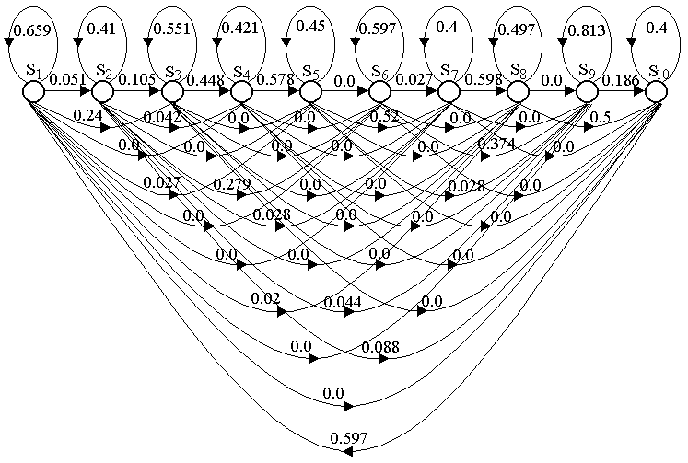
Figure 10: HMM of the characteristic behaviour representing clockwise cycling motion

Observation  type | Number of symbol sequences | Range of symbol sequences  length | Average symbol sequence length
tr₀ | 150 | 4 - 66 | 36
tr₁ | 150 | 7 - 66 | 36
tr₂ | 150 | 7 - 65 | 37
ntr₀ | 138 | 2 - 29 | 12
ntr₁ | 138 | 2 - 39 | 12
ntr₂ | 138 | 2 - 30 | 11
Table 3: Statistics of symbol sequences from observations tr₀ - tr₂ and ntr₀ - ntr₂

5.2.1. QUALITATIVE BEHAVIOUR CONCEPTUAL CLUSTERING FOR TREATED AND NONTREATED LABORATORY ANIMALS

The input data are symbol sequences obtained from observations (tr₀ - tr₂ and ntr₀ - ntr₂). The number of symbol sequences of input sets are given in table 3. Table 4 gives an overview of clustering results for observations of treated (tr₀ - tr₂) and nontreated (ntr₀ - ntr₂) laboratory animals. As significant clusters are considered only those clusters whose number of symbol sequences is greater than the number of clusters.

Laboratory animal class  (tr-treated, ntr-nontreated) | Number of significant clusters / total number of clusters
tr₀ | 2 / 22
tr₁ | 2 / 23
tr₂ | 2 / 2
ntr₀ | 1 / 10
ntr₁ | 1 / 9
ntr₂ | 2 / 17
Table 4: The results of conceptual clustering

In [14] we have concluded that the choice of attributes based on the spatio-temporal model has significant influence on cluster generation. Performing the analysis of clustering results we have shown that obtained clusters cannot adequately represent characteristic behaviours [13]. We propose a fusion of supervised and unsupervised procedures in order to give more adequate characteristic behaviour models. Our former work dealing with the development of the LABAQM system is presented in [15].

5.3. FUSION OF THE SUPERVISED AND UNSUPERVISED LEARNING PROCEDURES

In order to obtain better results in HMM training, the training set should contain a large number of behaviour patterns (specially in the case of left-right HMMs which are usually used in modelling of processes changing in time) [21]. The idea is to unify annotated symbol sequences and symbol sequences from clusters obtained by the unsupervised learning procedure (Figure 5). Resulting learning sets are the base for learning of more robust behaviour models, which are used for behaviour analysis.

Symbol sequences from the clusters obtained by unsupervised learning are evaluated by HMMs of characteristic behaviours. The clusters are marked with the type of behaviour for which the behaviour HMM gives the maximum probability for the majority of symbol sequences from the cluster (slow motion, clockwise cycling or counter-clockwise cycling). Table 5 shows the marking result for different significant clusters obtained by unsupervised learning procedure. Each cluster is marked with certain behaviour type if the major number of sequences is classified by the same HMM. The first column of the Table 5 represents the significant cluster of an observation; for example ntr_{2,2} is second significant cluster from list of 17 clusters (Table 4). Conceptual clustering for observations tr₀, tr₁ and tr₂ (treated animal) result with clusters marked as cycling (behaviour types 2 and 3). In all cases of nontreated animal there is one cluster recognised as slow motion.

Table 6 gives the number of annotated symbol sequences and symbol sequences from marked clusters. Symbol sequences obtained by supervised learning and symbol sequences from marked clusters represent the new learning set for HMM modelling which results with more robust behaviour models. The learning procedure for computing HMM parameters is the same as in supervised learning (Section 5.1.).

Observation  type, index of the significant cluster | Number of symbol sequences in a cluster | Number of marked symbol sequences with P_{max} for HMM₁ | Number of marked symbol sequences with P_{max} for HMM₂ | Number of marked symbol sequences with P_{max} for HMM₃ | Cluster behaviour type label (determined by the type of the majority of the sequences)
tr₀,₁ | 50 | 5 | 20 | 25 | 3
tr₀,₂ | 44 | 0 | 0 | 44 | 3
tr₁,₁ | 44 | 5 | 23 | 16 | 2
tr₁,₂ | 25 | 0 | 2 | 23 | 3
tr₂,₁ | 124 | 6 | 41 | 77 | 3
tr₂,₂ | 26 | 0 | 13 | 13 | undecided
ntr₀,₁ | 121 | 81 | 35 | 5 | 1
ntr₁,₁ | 119 | 55 | 25 | 39 | 1
ntr₂,₁ | 26 | 10 | 13 | 3 | 2
ntr₂,₂ | 78 | 33 | 18 | 27 | 1
Table 5: The results of the marking procedure of the clusters

6. BEHAVIOUR ANALYSIS

Behaviour analysis is performed with new HMMs created with the learning set of symbol sequences from the fusion of supervised and unsupervised learning. Behaviour analysis is given for the observations of type tr₃ and ntr₃ which have not been included in the behaviour learning stage.

Behaviour analysis starts with feature vector transformation procedure (Figure 6) of input data obtained from the above observations. The symbol sequences are then passed to the HMMs of characteristic behaviours. Each model generates an output probability for each symbol sequence. The HMM, which generates the greatest probability for a symbol sequence is chosen as the behaviour type.

The results can be seen in Table 7. It can be seen that in both observations, characteristic behaviours have been correctly recognised. In this pharmacological experiment it shows that the LABAQM system, for the laboratory animal behaviour analysis, recognises a characteristic behaviour with satisfactory accuracy for an unknown animal behaviour observation.

 | 1. Slow motion | 2. Counter-clockwise cycling (ABCD) | 3. Clockwise cycling (ADCB)
Number of annotated symbol sequences | 302 | 69 | 66
Observation type, index of the significant cluster | ntr₀,₁  ntr₁,₁  ntr₂,₂ | tr₁,₁  ntr₂,₁ | tr₀,₁  tr₀,₂  tr₁,₂  tr₂,₁
Number of symbol sequences obtained by fusion of annotated symbol sequences and those from marked cluster | 620 | 139 | 309
Average length of symbol sequences | 9 | 31 | 34
Table 6: The unification of sequences in the fusion of supervised and unsupervised learning

Observation type | Number of marked symbol sequences with P_{max} for HMM₁ | Number of marked symbol sequences with P_{max} for HMM₂ | Number of marked symbol sequences with P_{max} for HMM₃ | Behaviour type (determined by the type of the majority of the sequences)
tr₃ | 5 | 32 | 113 | 3
ntr₃ | 85 | 32 | 21 | 1

Table 7: The results of the bahaviour analysis

7. CONCLUSION

In this paper we propose an approach which combines a spatio-temporal model, expert knowledge and statistical modelling procedures in order to develop qualitative animal behaviour models. In order to achieve more robust behaviour models a fusion of supervised and unsupervised learning procedures is applied. These models are used in the LABAQM system for automatic recognition of behaviour patterns of animals during pharmacological experiments.

The LABAQM system has the following characteristics:
• It introduces a spatio-temporal model, to define the mapping of object movements into symbols.
• Even with incomplete background knowledge the spatio-temporal model is the base for automatic qualitative modelling.
• It uses HMMs as behaviour models for object behaviour types.
• In order to create more robust HMMs the fusion of unsupervised and supervised learning procedures is proposed.

In the experimental phase the LABAQM system proves that animal behaviour patterns can be automatically recognised for performed pharmacological experiments with satisfactory accuracy.

An HMM representing behaviour model can be the base for the simulation of animal behaviour. In our future work we intend to make further system extensions, with a wide scale of possible specific requirements dictated by further pharmacological experiments and expert demands.

8. REFERENCES
- Aggarwal, J.K.; Cai, Q.(1999): Human Motion Analysis: A Review, Computer Vision and Image Understanding, 73(3), 1999, pp.428-440.
- Bregler, C.(1997): Learning and Recognizing Human Dynamics in Video Sequences, In Conference on Computer Vision and Pattern Recognition, San Juan, Puerto Rico, 1997.
- Cohn, A.G.; Bennett, B.; Gooday, J.; Gotts, N.M.(1997): Representing and Reasoning with Qualitative Spatial Relations about Regions, in Spatial and Temporal Reasoning, edited by Oliviero Stock, Kluwer Publishing Company, pp. 97-134.
- Cohn, A.G.; Hazarika, S.M.(2001): Qualitative Spatial Representation and Reasoning: An Overview, Fundamenta Informaticae, 43, 2-32, IOS Press, 2001.
- Forbus, K.D.(1984): Qualitative Process Theory, Artificial Intelligence, 24:85-168, 1984.
- Gavrila, D.M.(1999.): The Visual Analysis of Human Movement: A Survey, Computer Vision and Image Understanding, vol.73(1), pp.82-98,1999.
- Kalafatić, Z.; Ribarić, S.; Stanislavljević, V.(2001): A system for Tracking Laboratory Animals Based on Optical Flow and Active Contours, 11th International Conference on Image Analysis and Processing (ICIAP 2001), Palermo, Italy, pp. 334-339.
- Kalafatić,Z.; Ribarić, S.; Stanisavljević, V.(2000): Real-Time Object Tracking Based on Optical Flow and Active Rays, 9th Mediterranean Electrotechnical Conference (MELECON 2000), Cyprus, vol. II, pp. 542-545.
- Kubat, M.; Bratko, I.; Michalski, R.S.(1998): A Review of Machine Learning Methods, in Machine Learning and Data Mining: Methods and Applications, edited by R.S. Michalski, I. Bratko, and M. Kubat, London, John Wiley & Sons, p.p. 3-69.
- Kuipers, B. J.(1986): Qualitative simulation, Artificial Intelligence, 29:289-338, 1986.
- Lance, G.N.; Williams, W.T.(1967): A General Theory of Classification Sorting Strategy, Computer Journal, No. 9, 19-73, 1967.
- Levenshtein, V.I.(1966): Binary Codes Capable of Correcting Deletions Insertions and Reversals, Cybernetics and Control Theory, 10:707-710, 1966.
- Matetić, M.; Ribarić, S.(2002): Qualitative Modelling Of Object Behaviour In The Dynamic Vision System Using Hidden Markov Models, Proceedings of the 11th Mediterranean Electrotechnical Conference MELECON 2002, May 7-9 2002, Cairo, Egypt, pp.570-574.
- Matetić, M.; Ribarić, S.(2002): Conceptual Clustering of Object Behaviour in the Dynamic Vision System Based on Qualitative Spatio-Temporal Model, Proceedings of MIPRO 2002 conference, section CIS, Opatija 2002, pp. 15-20.
- Matetić, M.; Ribarić, S.(2002): A System for the Behaviour Analysis of Laboratory Animal Based on Qualitative Modelling, Proceedings of the 6th International Conference on Intelligent Engineering Systems INES, Opatija 2002, pp. 273-278.
- Medioni, G.; Cohen, I.; Bremond, F.; Hongeng, S.; Nevatia, R.(2001): Event Detection and Analysis from Video Streams, IEEE Transactions on Pattern Analysis and Machine Intelligence, Vol.23, no.8, August 2001, pp. 873-889.
- Michalski, R.S.; Kaufman, K.A.(1998): Data Mining and Knowledge Discovery: A Review of Issues and a Multistrategy Approach, in Machine Learning and Data Mining: Methods and Applications, edited by R.S. Michalski, I. Bratko and M. Kubat, London, John Wiley & Sons, p.p. 70-112.
- Milligan, G.W.; Cooper, M.C.(1985): An Examination of Procedure for Determining the Number of Clusters in a Data Set, Psychometrika, 50, 159-179, 1985.
- Moeslund, T.; Granum, A.(2001): A Survey of Computer Vision Based Human Motion Capture, Computer Vision and Image Understanding, 81(3), March 2001, pp.231-268.
- Rabiner, L.R.; Juang, B.H.(1986): An Introduction to Hidden Markov Models, IEEE ASSP MAGAZINE, pp. 4-16, 1986.
- Rabiner, L.R.(1989): A Tutorial on Hidden Markov Models and Selected Applications in Speech Recognition, Proceedings of the IEEE, Vol.77, No.2, February 1989.
- Starner, T.; Weaver, J.; Pentland, A.(1998): Real-Time American Sign Language Recognition Using Desk and Wearable Computer Based Video, IEEE Transactions on Pattern Analysis and Machine Intelligence, Vol.20., No. 12, pp. 1371-1375, 1998.
- Vogler, C.; Metaxas, D.(1999.): Parallel Hidden Markov Models for American Sign Language Recognition, Proceedings of the ICCV(2) 1999: 116-122.
- Wren, C.; Azarbayejani, T.D.; Pentland, A.(1997): Pfinder: Real-time tracking of the human body, IEEE Transactions on Pattern Analysis and Machine Intelligence, 19(7):780-785,1997.

