Conceptual Clustering of Object Behaviour in
the Dynamic Vision System Based on
Qualitative Spatio -Temporal Model

Maja Matetić
Faculty of Philosophy Rijeka
University of Rijeka
Omladinska 14, 51000 Rijeka, Croatia
maja@mapef.pefri.hr

Slobodan Ribarić
Faculty of Electrical Engineering and Computing
University of Zagreb
Unska 3, 10000 Zagreb, Croatia
slobodan.ribaric@fer.hr

Abstract - A class of machine learning methods relevant to data mining and knowledge discovery concerns the problem of building a conceptual classification of a given set of entities. The choice of the attributes in describing a given input has crucial impact on the classes induced by a learner. We investigate the problem of attribute selection in an unsupervised learning task in the dynamic vision system. The input data obtained by tracking of the laboratory animal in two-dimensional scene is transformed on the base of the qualitative spatio-temporal model and background knowledge, resulting with qualitative description of behaviour. The qualitative approach reduces the number of attributes used to describe the training data in order to improve the quality of the concepts produced. Moreover, new attributes are derived as composite functions of the initial attributes. This data preprocessing is the base for conceptual clustering process which is formulated as clustering that exploits background knowledge and facilitate the interpretation task to user. Obtained clusters are the base for the behaviour analysis.

I. INTRODUCTION

One of the basic tasks of machine learning and data analysis is to automatically uncover the qualitative and quantitative patterns in data sets. When a large database is given, to discover the inherent patterns and regularities becomes a challenging task, especially when no domain knowledge is available or when domain knowledge is too weak. Because of the size of the database, it is almost impossible for a decision maker to manually abstract from it the useful patterns. Hence, it is desirable to have automatic pattern discovery tools to support various types of decision making tasks [5], [8].
A conceptual clustering method seeks not only a classification structure of entities (a dendogram), but also a symbolic description of the proposed classes (clusters). An important, distinguishing aspect of conceptual clustering is that, unlike in cluster analysis, the properties of class descriptions are taken into consideration in the process of determining the classes (clusters) [8].
This paper is concerned with the problem of the analysis of laboratory animal behaviour in the scene. The animal behaviour analysis is based on the quantitative data from the existing tracking application and incomplete domain background knowledge. The introductory description of the system is presented in [7].
The importance of the qualitative reasoning in making conclusions and predictions on the system behaviour, even without complete data, makes it suitable for many real world problems. The proposed system uses qualitative spatio-temporal representation and reasoning as the base in laboratory animal behaviour modelling and recognition [1], [2]. The qualitative approach reduces the number of attributes used to describe the training data in order to improve the quality of produced concepts. An overview of the latest research in the field of qualitative spatial representation and reasoning is given by Cohn et al. [2]. Qualitative Spatial Reasoning (QSR) has been used in computer vision for visual object recognition at a higher level which includes the interpretation and integration of visual information. In the work of Fernyhogh et al. [3] QSR technique has been used to interpret the results of low-level computations as higher level descriptions of the scene or video input. Their approach uses qualitative predicates to ensure that scenes which are semantically close have identical or at least very similar descriptions. An example of work using qualitative spatial simulation on the base of conceptual neighbourhood diagrams is the work of Rajagopalan [10].
The paper is organised as follows: Problem description is given in section II. Section III introduces the model of space and time. The data conceptual clustering procedure is described in section IV.

II. THE PROBLEM OF THE OBJECT BEHAVIOUR INTERPRETATION

We present our implementation of a component of the dynamic vision system used in laboratory animal behaviour recognition [7]. It is based on implemented methods of the frame sequence analysis and uses the incomplete background domain knowledge [4].
We are dealing with the cognitive phase of the laboratory animal behaviour analysis (as a part of the pharmacological tests): on the base of the detected object motion and computed trajectory attributes, implementing artificial intelligence methods, we need to analyse, recognise, and predict behaviours. Each of the object trajectories is the sequence of attribute vectors. Attribute vectors describe position and orientation in each of the trajectory point. Existing object tracking application generates, for the object present in the scene for N consecutive frames, the sequence S of N 2D picture coordinates and orientation in equal time intervals:
S = (((x₁,y₁),Θ₁),(x_{2,},y₂),Θ₂),...,(x_{k-1},y_{k-1}),Θ_{k-1}), (x_{k},y_{k}),Θ_{k}),...,(x_{N-1},y_{N-1}),Θ_{N-1}),(x_{N},y_{N}),Θ_{N}))) (1)
We deal with two types of observations: Observations of type tr are related to treated animals while observations of type ntr are related to nontreated animals.

III. THE SPATIO-TEMPORAL MODEL AND OBJECT BEHAVIOUR QUALITATIVE CONVERSION

The key to a qualitative representation is not simply that it is symbolic, and utilizes discrete quantity spaces, but that distinctions made in these discretisations are relevant to the behaviour being modelled - i.e. distinctions are only introduced if they are necessary to model some particular aspect of the domain with respect to the task in hand. The primitive spatial entities chosen by the qualitative spatial reasoning community, are qualitative region (Fig. 3) and qualitative orientation (Fig. 1).
The information provided from tracking applications is, by nature, quantitative and described by the sequence S of n 2D picture coordinates and orientation in equal time intervals (Equation 1) for the object in the scene. The laboratory animal behaviour analysis and recognition is based on orientation quantisation and also on the quantisation of two-dimensional space. Using the approximate zone or region rather than the exact object location will collapse broadly similar behaviours into equivalence classes leading to behavioural quantisation. Of course a scene cannot be arbitrarily segmented into regions - rather, the regions should be conceptually relevant to the physical structure of the domain rather than arbitrary.
For our problem the spatiotemporal model is the base for the qualitative conversion. The conceptuality of the clustering process is based on the qualitative modelling of space and time. The qualitative approach reduces the number of attributes used to describe the training data in order to improve the quality of the concepts produced.

A. Qualitative Region Attribute QR

In first step we deal with the topology view to the problem. It is to describe first complex attribute, which is the qualitative region (QR). To make easier the detection of the qualitative change in space, a rectangle mesh can be used (although the region transitivity graph is not limited to that choice of topology and depends only on qualitative region change detection procedure). The proper spatial extension of object projection in two-dimensional space (Fig. 2) is used, in order to obtain
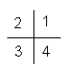
Fig. 1. Set of relations {1,2,3,4} representing second granularity level of orientation (orientation quantisation)
elementary rectangle of the mesh. The mesh is the result of a bisection of the scene two-dimensional space. Bisection stops when it reaches the elementary rectangle smaller than proper extension of the animal. In this way we have assured that the object cannot change behaviour qualitative state inside this elementary rectangle (for cause of orientation or velocity change). Table I gives description of the dimensions regarding the scene, the object in the scene and the elementary rectangle. The expert can choose values for qualitative region attribute by unifying those elementary rectangles, resulting in new topology frame where qualitative regions are of different shapes and sizes (Fig. 3). The set of values for the qualitative region attribute (QR) is thus U = {A, B, C, D, E, F}, and the qualitative region attribute is defined as:

QR: X × Y → U, (2)
where X={x, x_{min} ≤ x ≤ x_{max} } and
Y={y, y_{min} ≤ y ≤ y_{max}} (see Table I)

The size and the shape of qualitative regions depend on the distribution of animal positions in the scene. In order to get better results in the process of conceptual clustering of behaviours and behaviour analysis, the size and shape of qualitative regions depend on animal position distribution over qualitative regions A-F. The transitivity graph (Fig. 4) describes possible transitions between these qualitative regions. The finite alphabet U and transitivity graph form a part of the background knowledge.

B. Qualitative Orientation and Qualitative Time

The second step is to define the second attribute, which is the qualitative orientation. It is considered at level of qualitative region and is defined as (Fig. 1):

QO: [0°,360°] → {1, 2, 3, 4}, (3)

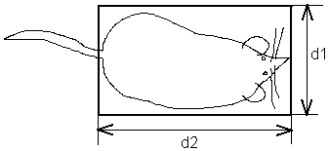
Fig. 2. Spatial extension of the laboratory animal

TABLE I
SCENE AND OBJECT DIMENSIONS
Width of spatial extension of lab. animal (d1 in Fig. 2) | 30 pixels (≈ 3 cm) (Background knowledge)
Length of spatial extension of lab. animal (d2 in Fig. 2) | 50 pixels (≈ 5 cm)  (Background knowledge)
Scene width | 180 pixels (≈18 cm)
Scene length | 320 pixels (≈ 32 cm)
Elementary rectangle length (x axe) | 40 pixels (≈ 4 cm)
Elementary rectangle width (y axe) | 22.5 pixels (≈ 2.25 cm)
x_{min}, x_{max} | 10 pixels, 330 pixels
y_{min}, y_{max} | 25 pixels, 205 pixels
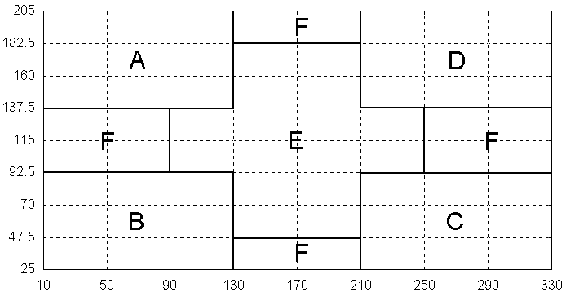

Fig. 3. Qualitative region attribute values

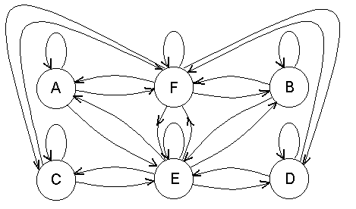
Fig. 4. Transitivity graph for qualitative region attribute

The set of values for the qualitative orientation attribute is {1,2,3,4}. The measure of the activity inside a qualitative region (constant value of QR attribute) we define as the average time duration between two changes of qualitative orientation (Av_t). Av_t attribute is getting its value from the set {1, 2, 3, ..., n} depending on the value of Av_t and on the number of ranges n chosen by an expert (Table II). In our case n = 3 so the set of values for Av_t is V = {1, 2, 3}. The subranges of values for Av_t depend on distribution of Av_t values in the range of [1, 400].
Complex quantitative behaviour is split into n simple quantitative behaviours of equal time duration T (Table II). Each of these quantitative samples is converted to the qualitative behaviour on the base of spatiotemporal model and tracking data values. The number of symbols in qualitative behaviour depends on the qualitative behaviour duration T and on the object activity in the scene. T can be considered as a part of the background knowledge because it depends on characteristics of behaviours that are to be detected.

C. Qualitative Conversion

Qualitative conversion is based on the spatiotemporal model and the input data obtained by tracking (Equation (1)). It produces the set of qualitative behaviours. Qualitative behaviour is defined as:

QB: S_{T} → {qb, qb=((qr₁,av_t₁), (qr₂,av_t₂), .., (qr_{i},av_t_{i}), .., (qr_{m},av_t_{m})), 1 ≤ m ≤ T, qr_{i}∈ U, av_t_{i}∈V} (4)

where S_{T} is

S_{T} = (((x_{i+1},y_{i+1}),Θ_{i+1}),((x_{i+2},y_{i+2}),Θ_{i+2}),...,
((x_{i+T1},y_{i+T1}),Θ_{i+T1}),((x_{i+T},y_{i+T}),Θ_{i+T}))), 1≤ i ≤ N (5)

(N is the number of frames in a video sequence)
So qualitative behaviour value qb is a sequence of vectors of complex attribute values (qr_{i} and av_t_{i}) or we can say that qualitative behaviour is a sequence of qualitative states:

qb=(qs₁, qs₂, ..., qs_{m}), 1 ≤ m ≤ T, (6)

Qualitative state QS is a function of qualitative region attribute and Av_t attribute:

QS: U x V → G, (7)

where on the base of background knowledge we have:
U = {A, B, C, D, E, F}, V = {1, 2, 3},
G = {A, AA, AAA, B, BB, BBB, C, CC, CCC, D, DD, DDD, E, EE, EEE, F, FF, FFF}.
The qualitative conversion examples are given in Fig. 5(a) and 5(b).

TABLE II
Background knowledge provided by an expert

T | Time duration of elementary video sequence = Duration of qualitative behaviour QB  T = (k-i) Δt; k-i = 400; k, i are frame indices (400 frames = 400/18 sec. = 22.2 sec.)
U | U={A, B, C, D, E, F} - Set of qualitative region symbols and the description of qualitative region attribute in two-dimensional space (transitivity graph)
n | Number of Av_t qualitative ranges  (V={1,2, 3}, for n=3)

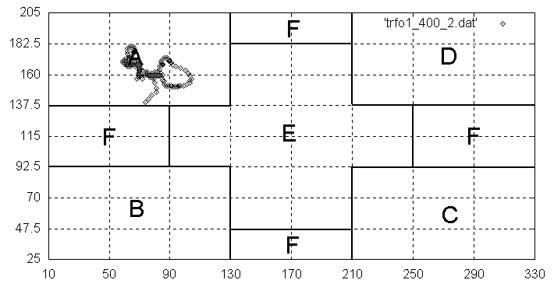
1. A A
(a)
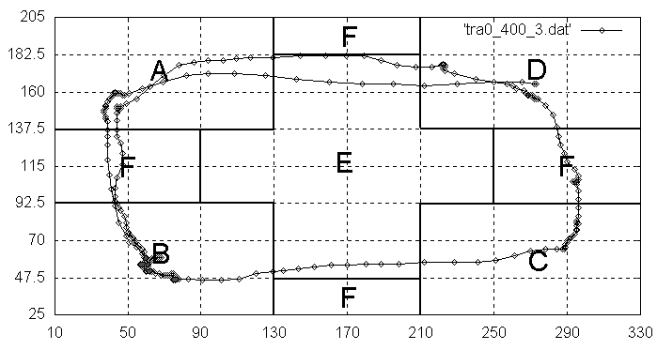
1. B F A A E E D D F C E E E B B B F F A E D
(b)
Fig. 5. Qualitative conversion examples
IV. CONCEPTUAL CLUSTERING OF QUALITATIVE BEHAVIOURS

Qualitative conversion is a kind of clustering method, which converts a sequence of attribute vectors of time duration T to a string of symbols from the finite alphabet. The alphabet is determined by the choice of the ontology of space and time and the background knowledge. Conceptual clustering of animal behaviours is implemented as hierarchical clustering [6] based on behaviour patterns resulting from qualitative conversion.
The input for the hierarchical clustering method is the set of m patterns. The result of the hierarchical clustering is a tree representing all possible resulting clusters - a dendogram (Fig. 6).
Hierarchical clustering method has three steps [6]:
1. Step: Compute triangular matrix of distances between input patterns.
It includes computing of similarities between pairs of strings from Fig. 6 using Levenshtein distance D_{L}(x,y) [12]. These strings of symbols are of the different length so to determine similarity the dynamic programming method is used.
2. Step: If the distance between clusters S_{i} and S_{j} (in the first iteration every cluster contains only one pattern) is the smallest (the greatest similarity), we merge them in one cluster. We achieve cluster S_{i}+S_{j}. Distances between new cluster and remaining clusters D(S_{i}+S_{j}, S_{k}) we compute as:

D(S_{i}+S_{j}, S_{k}) = 1/2 D(S_{i}, S_{k}) + 1/2 D(S_{j}, S_{k}) + 1/2 |D(S_{i}, S_{k}) - D(S_{j}, S_{k})| (8)

Distance D(S_{i}+S_{j}, S_{k}) is equal to the distance between the most distant patterns from the clusters S_{i}+S_{j} and S_{k}.
3. Step: If new distance matrix has more than one column we repeat step 2 else we end the process. The result is a dendogram of patterns.

1.FDDFEFABFEFCFEFBAFFE
2.EFBAFEFCFBAAFEFDFABFC
3.CDFAABFEFCDFABFCFCCC
4.CFEFAAFEFEFBAFDCFCFEFABAFFBA
5.AAFEFDCFEFABFCDFABFCDFA
6.ABFCDFABFCDFABFCDFAB
7.BFFEFBAAFEFCFBAFEFCFBAFD
8.CFEFBABFEFCDFABFCDFEFABFCDFA
9.ABFCDFBAFABFEFCDFEFBBAF
10.FAAFDCFBAAFEFCFEFBAAFEFDCFB
11.BAFEFCDFAFABFCDFABFCDFABFCDF
12.FABFEFCDFABFCFCDFABFCDFABFCDFAB
13.BFCDFABFCFCDFDDCFBAFDCFBAF
14.FDFABFABFCDFABFCFCDFABFEFCFCDFA
15.ABFCFEFABAFDCFEFBAFDCFEFBAFEFDC
16.DFABFEFDFABFCDFABFCDFEFAB
17.BFEFCFCFABFCDFABFEFEFCDFAFABFEFC
18.CDFABFEFCDFABFEFCDFABFCDFA
19.ABFCDFABFCDFABFDFEFABFEFC
20.CFCDFABFCDFABFCDFEFABFEFCD

Fig. 6. A part of qualitative behaviours obtained for observation tr₀

We evaluate second order correlation coefficient PB in order to determine the best dendogram cut ([9]):
$\text{PB} = \left({\overline{D}}_{b} −{\overline{D}}_{w}\right) \frac{\sqrt{\frac{f_{w }f_{b}}{n_{d}^{2}}}}{s_{d}}$, (9)
where:
D_{b} is average value of distances between patterns from different clusters,
D_{w} is average value of distances between patterns inside clusters,
f_{w} is number of pairs of patterns inside clusters,
f_{b} is number of pairs of patterns from different clusters,
n_{d} = (f_{w} +f_{b}) total number of pairs of patterns and

sd is standard deviation of distances between patterns from the average pattern distance.
The second order correlation coefficient PB we evaluate for every level in clustering hierarchy. Dendogram cut is chosen for the maximum value of the correlation coefficient PB.

A. Example 1: An illustration of the conceptual clustering for a small number of input patterns

The goal is to determine the dendogram of patterns for the input set of patterns in Fig. 8. We compute pattern distances (using Levensthein distance)
D(i,j)=|x_{i}-x_{j}|; i=1,2,...,20
and achieve the triangular distance matrix. We repeat conceptual clustering step 2 until all patterns are in one cluster, resulting with the dendogram of patterns (Fig. 7). Evaluation of the second order correlation coefficient PB is accomplished according to Equation 9.
Table III shows its values for different levels in dendogram. It can be seen that:
PB(10) > PB(8) > PB(9) > PB(11) > PB(7) > PB(5) > PB(12) > PB(6) > PB(13) > PB(4) > PB(14) > PB(15) > PB(3) > PB(16) > PB(17) > PB(18) > PB(19) > PB(2) >PB(1) = PB(20) (10)
so the best dendogram cut gives 10 clusters. Fig. 8 presents resulting clusters of patterns. As significant clusters we can consider only those clusters with number of patterns greater than the number of clusters. In this example there is no such cluster, because the number of input patterns are too small. Detection of significant clusters is possible mostly for large number of input patterns, as we will see in the next example.

TABLE III
Evaluation of the correlation coefficient PB

i | PB(i) | i | PB(i)
1 | 0 | 11 | 0.5873
2 | 0.1206 | 12 | 0.4816
3 | 0.4021 | 13 | 0.4311
4 | 0.4254 | 14 | 0.4176
5 | 0.4392 | 15 | 0.4045
6 | 0.4314 | 16 | 0.3717
7 | 0.5785 | 17 | 0.3362
8 | 0.5884 | 18 | 0.2852
9 | 0.5882 | 19 | 0.2240
10 | 0.5945 | 20 | 0

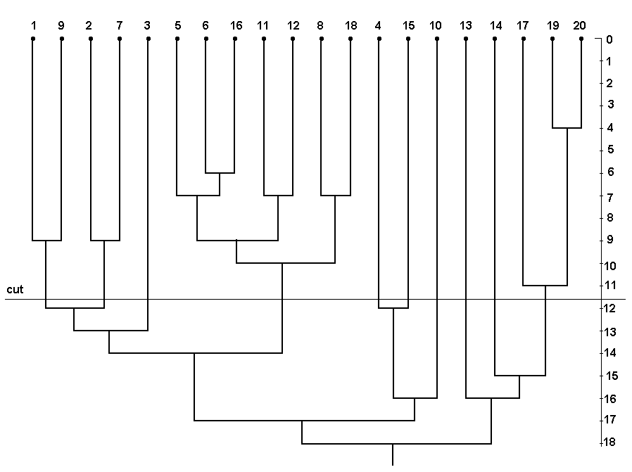
Fig. 7. Dendogram of patterns from Fig. 6

I CLUSTER:
1.FDDFEFABFEFCFEFBAFFE
9.ABFCDFBAFABFEFCDFEFBBAF
II CLUSTER:
2.EFBAFEFCFBAAFEFDFABFC
7.BFFEFBAAFEFCFBAFEFCFBAFD
III CLUSTER:
3.CDFAABFEFCDFABFCFCCC
IV CLUSTER
4.CFEFAAFEFEFBAFDCFCFEFABAFFBA
V CLUSTER:
5.AAFEFDCFEFABFCDFABFCDFA
6.ABFCDFABFCDFABFCDFAB
16.DFABFEFDFABFCDFABFCDFEFAB
11.BAFEFCDFAFABFCDFABFCDFABFCDF
12.FABFEFCDFABFCFCDFABFCDFABFCDFAB
8.CFEFBABFEFCDFABFCDFEFABFCDFA
18.CDFABFEFCDFABFEFCDFABFCDFA
VI CLUSTER:
10.FAAFDCFBAAFEFCFEFBAAFEFDCFB
VII CLUSTER:
13.BFCDFABFCFCDFDDCFBAFDCFBAF
VIII CLUSTER:
14.FDFABFABFCDFABFCFCDFABFEFCFCDFA
IX CLUSTER:
15.ABFCFEFABAFDCFEFBAFDCFEFBAFEFDC
X CLUSTER:
17.BFEFCFCFABFCDFABFEFEFCDFAFABFEFC
19.ABFCDFABFCDFABFDFEFABFEFC
20.CFCDFABFCDFABFCDFEFABFEFCD
Fig. 8. Resulting clusters of patterns

B. Example 2: Qualitative behaviours conceptual clustering for treated and nontreated laboratory animals

The input data in following example are sets of patterns resulting from qualitative conversion. Qualitative conversion is based on the quantitative data from observations (tr₀-tr₃ and ntr₀-ntr₃) and on the spatiotemporal model. Table IV gives an overview of the obtained results of clustering procedure for treated (tr₀-tr₃ observation type) and nontreated (ntr₀-ntr₃ observation type) laboratory animals.
Behaviour clusters marked as significant are those with the number of behaviour patterns greater than the number of clusters. Table V shows behaviour cluster prototypes for observations of type tr and ntr. Behaviour cluster prototype is chosen as the pattern, which presents cluster centre. It can be noticed that in the tr type observations, the change of qualitative region is more frequent than in the case of observations of type ntr, reflecting in longer symbol sequences. In the other hand the behaviours for observations ntr are characterised with small object movement. Fig. 9 and 10 show heat maps for treated and nontreated object motion (15000 frames). We can recognise some of the behaviours described by the cluster prototypes (for example cycling in Fig. 9 and small motions in Fig. 10).

TABLE IV
NUMBER OF CLUSTERS AS THE RESULT OF CLUSTERING FOR TREATED AND NONTREATED ANIMALS

Laboratory animal class  (tr-treated, ntr-nontreated) | Number of significant clusters / total number of clusters
tr₀ | 2 / 22
tr₁ | 2 / 23
tr₂ | 2 / 2
tr₃ | 2 / 23
ntr₀ | 1 / 10
ntr₁ | 1 / 9
ntr₂ | 2 / 17
ntr₃ | 1 / 19

TABLE V
BEHAVIOUR PROTOTYPES IN THE CASE OF TREATED AND NONTREATED LABORATORY ANIMAL

tr₀ | 1.DEEEFBBBEECCC  2.AAAEDFCCEEEBFAAEDDFFCCEEBBFFAAEDDFCEB
tr₁ | 1.CCCFFDDDEEEBBFAAE  2.BBEEEDDFFECEEFBFAEEDDFCCEEB
tr₂ | 1.DDEFCCEEFBBFFAAEEDFFCCEEBFFAEED  2.CCEFEBFFFAEEDDFFCFFDEEEAAEFBBECCFFDEEEFFFBEEFFCC
tr₃ | 1.BBFAAAEEDDFCCEEFEBB  2.CCEBFFAFAEEEDDFEEEBBFFAAEDDFCEEBB
ntr₀ | 1.AAFAEE
ntr₁ | 1.EEFFAFF
ntr₂ | 1.EFFDDFEEEF  2.FFF
ntr₃ | 1.FFF

On the base of these results we can conclude that the choice of attributes based on the background knowledge (Table II) has significant influence on cluster descriptions. So the conceptual clustering algorithm based on the complex attributes rather than simple attributes can be considered as conceptual clustering. This conceptual clustering property makes easier the behaviour recognition, interpretation and prediction task, which are the topics of the future research.

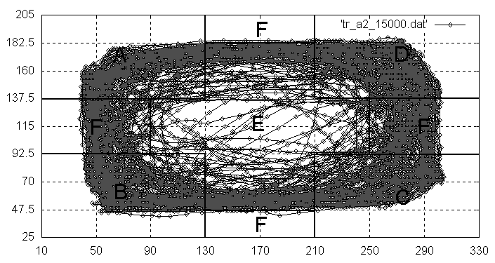

Fig. 9. Heat map for period of 15000 frames (13.9 minutes) for observation tr₂ (treated animal)

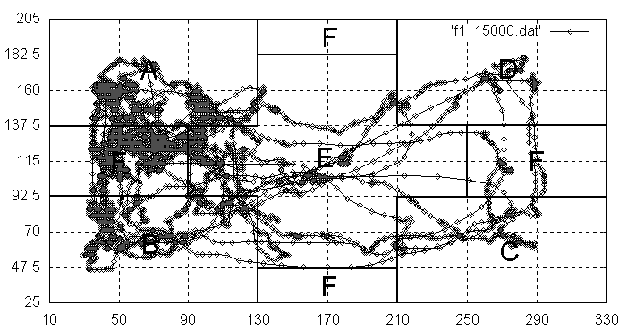

Fig. 10. Heat map for period of 15000 frames (13.9 minutes) for observation ntr₁ (nontreated animal)

V. CONCLUSION

This work is focusing on the discovery of the laboratory animal behaviour in the scene. Results show the benefits that we can obtain from using prior knowledge in the clustering task regarding accuracy and comprehensibility.
The presented method has following advantages:
• It introduces a kind of underlying modelling language, defining how to map the images into symbols.
• The spatio-temporal model even with incomplete background knowledge is the base in building of the "behaviour alphabet" and qualitative model.
Future research will be concerned with the modelling of the clusters resulting from unsupervised clustering procedure.

REFERENCES

[1] A.G.Cohn, B.Bennett, J.Gooday and N.M.Gotts, Representing and Reasoning with Qualitative Spatial Relations about Regions, in Spatial and Temporal Reasoning, Oliviero Stock (Ed.), Kluwer Publishing Company, pp. 97-134, 1997.
[2] Cohn, A.G. and Hazarika, S.M., "Qualitative Spatial Representation and Reasoning: An Overview", Fundamenta Informaticae 43(2001), 2-32, IOS Press
[3] Fernyhough, J., Cohn, A.G. and Hogg, D., "Constructing qualitative event models automatically from video input", Image and Vision Computing, 18, 2000, pp. 81-103.
[4] Kalafatic, Z., Ribaric, S. and Stanisavljevic V., "Real-Time Object Tracking Based on Optical Flow and Active Rays", The 9th Mediterranean Electrotechnical Conference (MELECON) 2000, Cyprus, May 2000, vol. II, pp. 542-545.
[5] Kubat, M.,Bratko,I. and Michalski, R.S, A Review of Machine Learning Methods, in Michalski, R.S., Bratko,I. and Kubat, M.(Eds), Machine Learning and Data Mining: Methods and Applications, London, John Wiley & Sons, p.p. 3-69,1998
[6] Lance, G.N. and Williams, W.T, A General Theory of Classification Sorting Strategy, Computer Journal, No. 9, 19-73, 1967.
[7] Matetić, M. and Ribarić, S., "Qualitative Modelling and Reasoning About Object Beaviour in the Dynamic Vision System", Proceedings of the tenth Electrotechnical and Computer Science Conference ERK 2001, 24-26 September 2001, Portorož, Slovenia, Volume B, pp. 293-296.
[8] Michalski, R.S. and Kaufman,K.A., Data Mining and Knowledge Discovery: A Review of Issues and a Multistrategy Approach, in Michalski, R.S.,Bratko,I. and Kubat,M.(Eds), Machine Learning and Data Mining: Methods and Applications, London, John Wiley & Sons, p.p. 70-112,1998
[9] Milligan G.W., Cooper, M.C., "An Examination of Procedure for Determining the Number of Clusters in a Data Set", Psychometrika, 50, 159-179, 1985.
[10] Rajagopalan, R., "A model for integrated qualitative spatial and dynamic reasoning about physical systems", Proceedings of American Conference on AI (AAAI-94), 1994, pp.1411-1417.
[11] Talavera, L. and Bejar, J., "Integrating Declarative Knowledge in Hierarchical Clustering Tasks", Proceedings of the International Symposium on Intelligent Data Analysis (pp. 211-222), Amsterdam, The Netherlands, Springer Verlag, 1999.
[12] Wagner, R.A., Fisher, M.J., "The String to String Correction Problem", Journal of the Association for Computing Machinery, 21(1), 168-173, 1974.
[13] Wong, A.K.C., Wang, Y., "High Order Pattern Discovery from Discrete-Valued Data", IEEE Transactions on Knowledge and Data Engineering,Vol.9, No.6, 1997, pp.877-893

